**Math 120**

**Test 2B**

**Student Name: _______________________________________ Student Number: ______________________**

**Directions:**

* SHOW ALL YOUR WORK OR JUSTIFICATION FOR ANSWERS *ON THE TEST*. Scrap paper is sometimes hard to read and I want to give you partial credit!
* Simplify all answers.
* Round answers as indicated.
* Include units with final answers.

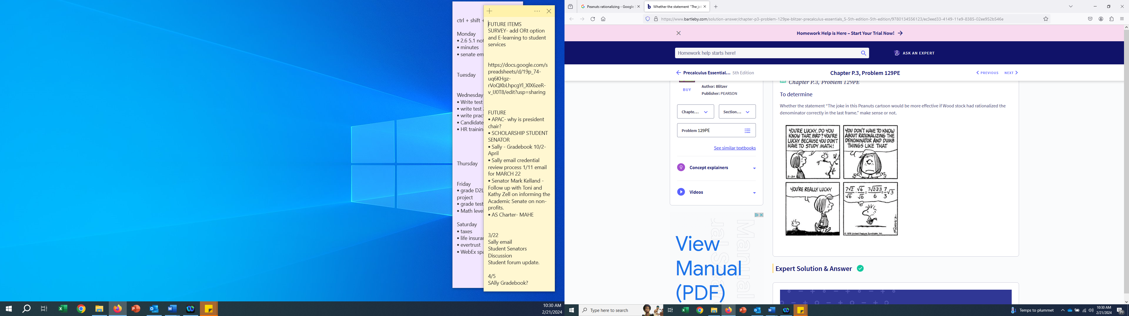

OPTIONAL EXTRA CREDIT QUESTION:

Find the area of the property enclosed. The stream frontage is 800 ft in length and the property line is 3200 feet in length. HINT: Area of a triangle = ½ *b*h. Round to the nearest hundredth.

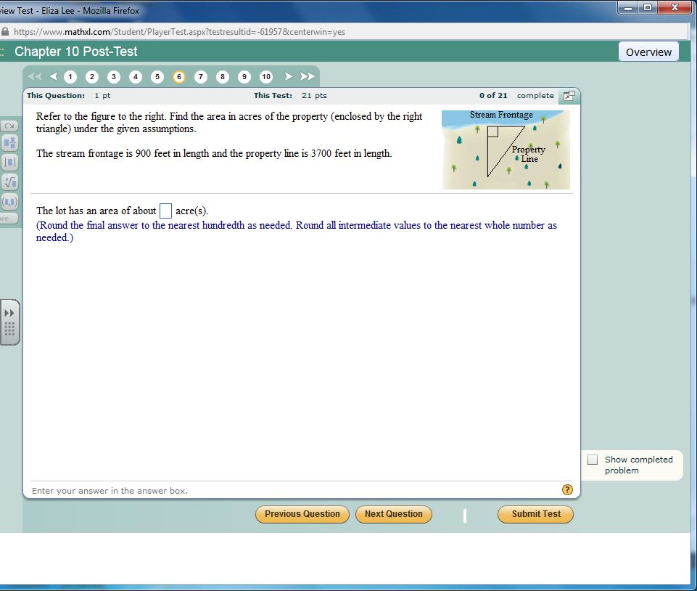

* 1. Solve the linear equations.

1.  b. 

a.________________ b.________________

* 1. Use the conditions to solve the linear equation.

1. Suppose and . Find all *x* values such that .

a.______________________

1. Suppose and . Find all *x* values such that .

b.______________________

1. Find the zero(s) for the function 

c.______________________

* 1. Use the following rational equation.



a. Identify any excluded values. a.____________________

b. Solve the rational equation. Do not include values that are excluded, when applicable.

b.__________________

* 1. Use the following rational equation.



a. Identify any excluded values. a.____________________

b. Solve the rational equation. Do not include values that are excluded, when applicable.

b.____________________

5. Later in the semester, procrastinating students have more symptoms of physical illness!

a. At the beginning of the semester, procrastinators reported an average of 0.7 symptoms that increased at a rate of 0.4 symptoms per week. Write a function that models the average number of symptoms after *x* weeks.

______________________

b. At the beginning of the semester, non-procrastinators reported an average of 2.2 symptoms that increased at a rate of 0.15 symptoms per week. Write a function that models the average number of symptoms after *x* weeks.

______________________

c. By which week in the semester did both groups report the same number of symptoms of physical illness?

______________________

d. For that week, how many symptoms were reported by each group?

______________________

e. How many physical symptoms will the procrastinators report in week 16?

______________________

6. You love to read and recently found the full Harry Potter series available to buy! You paid $166.41 for the entire series with matching trunk box. If Michigan has a 6% sales tax, find the cost of the Harry Potter series before the MI sales tax. Interpret your answer in a complete sentence within the context of the question.

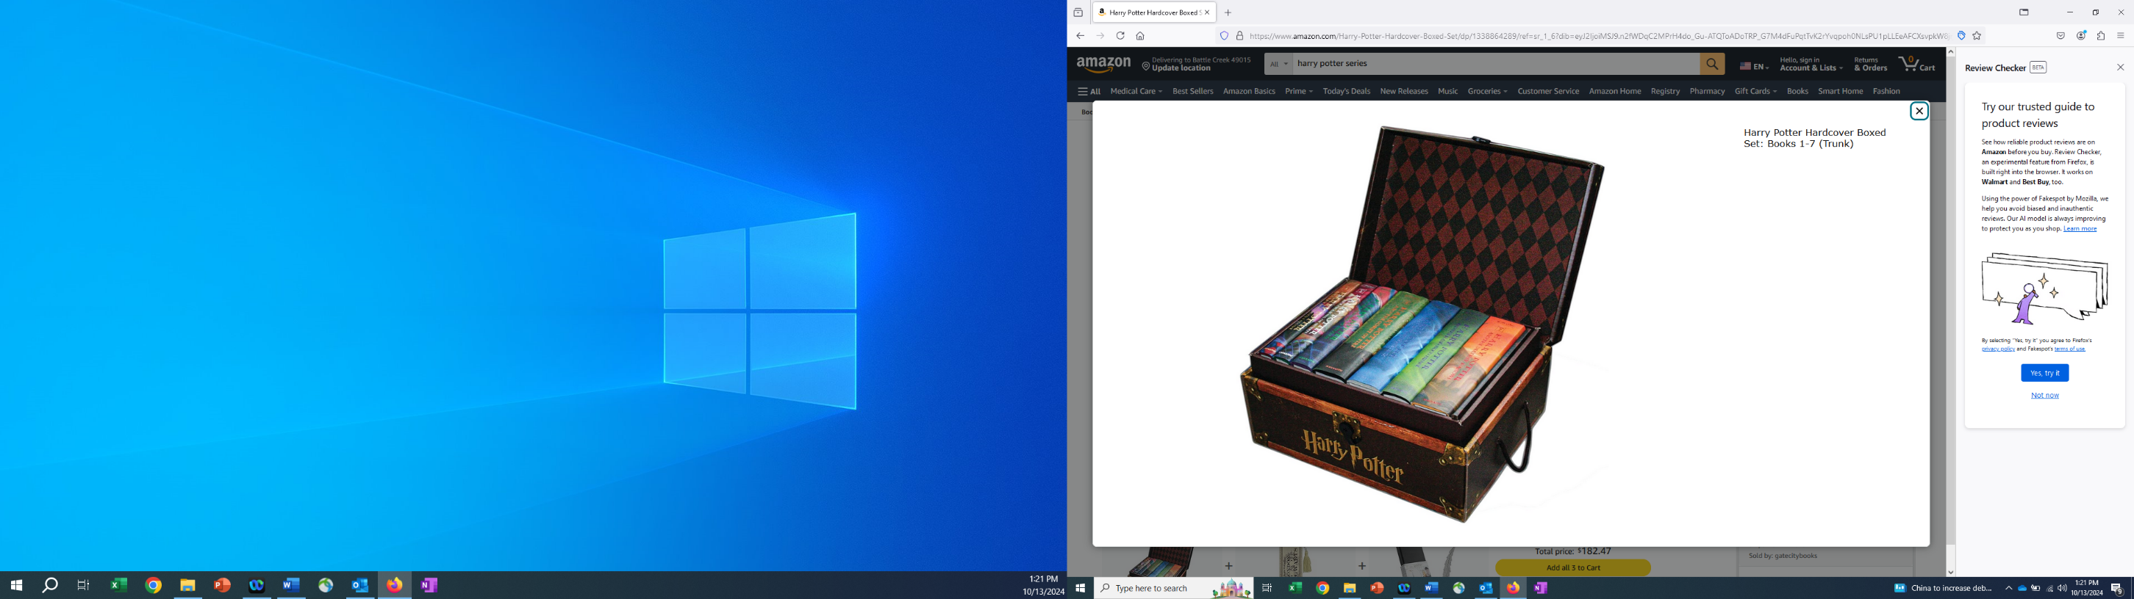

_______________________________________________________

_______________________________________________________

_______________________________________________________

_______________________________________________________

7. In 2020 there were two TikTok influencers Batman and Robin. Batman started with 15,000 followers and increased each year by 2000 followers per year. Robin started with 30,000 followers but got canceled and has been losing 3000 followers per year.

a. Let *x* represent the number of years since 2020. Write (DO NOT SOLVE) an equation that can be used to find how many years after 2020 that Batman and Robin will have the same number of influencers.

__________________________________________________________

b. The following table is based on your equation from part *a*. Y1 represents one side of the equation and Y2 represents the other side of the equation.

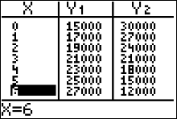

Use the table to answer these questions: In *which year* will the TikTokers have the same number of followers? What will the number of followers be in that year?

Year_____________________________

Number of Followers_____________________________

8. Solve the following inequalities. Other than no solution, use interval notation to express solution sets and graph each solution set on a number line.

a.  b. 

a. __________________ b. __________________

9. Solve the following inequalities. Other than no solution, use interval notation to express solution sets and graph each solution set on a number line.

a. 

a. __________________

b. Suppose that and . On what interval is 

b. __________________

10. You are trying to find a cell phone data plan for your grandmother. Since she doesn’t use internet or apps very often, you don’t want to get an unlimited data plan. Verizon has a monthly fee of $52 with a charge of $18 per gigabyte (GB). AT&T has a monthly fee of $32 with a charge of $22 per GB. How many whole number GB of data will your grandma have to use for Verizon to be the better deal? Interpret your answer in a complete sentence with the context of the question.

__________________________________________________________________________________________

__________________________________________________________________________________________

__________________________________________________________________________________________

11. Solve the system of linear equations by the method of your choice.

a.  b. 

a. __________________ b. __________________

12. In February of 2024 AT&T cellphone coverage went down all across the world! Many cellphone users were annoyed while Boomers were praising their land lines. The function models the number of land-line customers in the US, in millions, *x* years after 2000. The function models the number of cellphone customers, in millions, *x* years after 2000.

a. Determine the year when the number of cellphone customers and land line customers was the same. Round to the nearest year.

______________________

b. How many millions of cell phone customers were there for this year?

______________________

13. Perform the operations as indicated. Put your answer in standard form a+b*i*.

a.  __________________

1.  __________________
2.  __________________

14. Perform the operations as indicated. Put your answer in standard form a+b*i*.

a.  b. 

a. __________________ b. __________________

15. Perform the operations as indicated. Put your answer in standard form.

a.  b. 

a. __________________ b. __________________

16. For each quadratic equation, pick the most *efficient* method for solving the equation. Circle one option. DO NOT SOLVE.

a.  Square root property Factoring Quadratic Formula

b.  Square root property Factoring Quadratic Formula

c.  Square root property Factoring Quadratic Formula

d.  Square root property Factoring Quadratic Formula

e.  Square root property Factoring Quadratic Formula

17. Solve the following quadratic equations using any method of your choice. Give the EXACT answer.

a.  b. 

a. __________________ b. __________________

18. The graph of the quadratic function  follows:

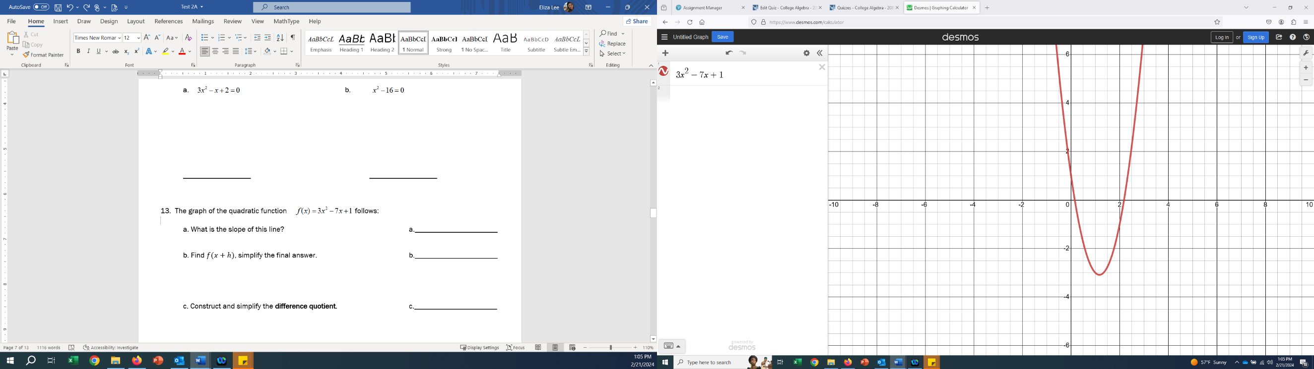 a. Identify the zeros by plotting the points DIRECTLY onto the graph.

b. The zeros plotted are irrational (cannot be expressed as a fraction or whole number). Find the EXACT values of the zeros for the function.

__________________

19. Playoffs have started for the Detroit Tigers Major League Baseball team. One of the catchers, Jake Rogers, was complaining to first baseman Spencer Torkelson that he has to throw farther to second base than Torkelson does. Jake Rogers says “Throwing from home base to second base is farther than throwing from first base to second base.” Is Jake Rogers right? How far is it from home base to second base? Refer to the picture below. Round to the nearest hundredth of a foot. Interpret your answer in a complete sentence within the context of the question.



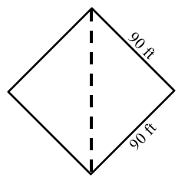



__________________________________________________________________________________________

__________________________________________________________________________________________

__________________________________________________________________________________________

20. Oh no! There has been a big storm and a tree has fallen on your house. The 30.5 foot tree is leaning against your house. The base or trunk of the tree missed your sidewalk and is 5 feet from the bottom of your house. If the tree reaches the top of the flat roof, how tall is your house? Round to the nearest foot. DRAW A PICTURE to help you.

_____________________

**Formula Sheet: Math 120**

**Straight Line**

Slope Intercept form Point-slope form Slope

  

**Difference Quotient Quadratic Formula**

 

**Logarithms**

  

**Distance**:  **Midpoint**: 

**Circle**: 

**Quadratic Function**

, Vertex =  , Vertex = 

**Compound Interest**:  **Continuous Compound Interest:** 

**Arithmetic Sequence Geometric Sequence**

 Finite:  

 Infinite: , 

**Even function Odd function**

 